**Launch Jmeter**

1. Go to <file path>/apache-jmeter-5.2.1/bin/jmeter.bat
2. JMeter launch and will be seen below

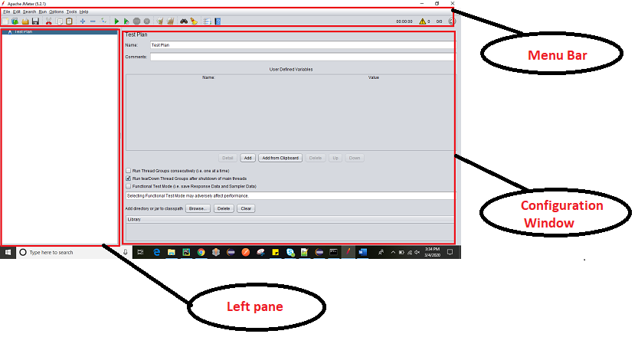

**Configuration Window**

User defined Variable

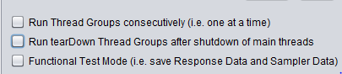

1. **Run Thread Groups consecutively**: If Test Plan can have one or more than Thread Group then they will execute one after the other.
2. **Run teardown Thread Groups after shutdown of main threads:** It execute after test execution. It is use for cleaning logs and reporting format.
3. **Functional Test Mode:** Sampler data and response data are saved in listeners.

**Test Plan**

This is the container where user add the elements required for JMeter test.

It Store all elements like Thread Group, Timers etc.

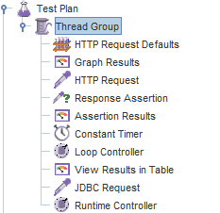

**Elements of Test Plan**

**Thread Group**

**Description:** It is collection of Threads called as Thread Group one thread similar one real user request.

**How to Add:** Right click on Test Plan. Add -> Threads (Users) - > Thread Group

**Component**:

Action to be taken after Thread Sampler

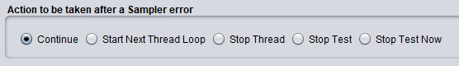

**Continue**: To ignore error and move to next element.

**Start Next Thread Loop**: Stop current thread and start next.

**Stop Thread:** Stop current thread execution.

**Stop Test:** Stop entire test execution.

**Stop Test Now:** the entire test will be strop abruptly

Thread Properties

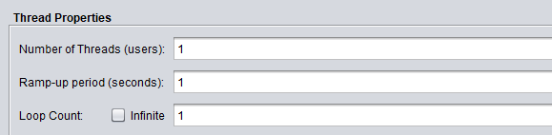

**Number of Threads (users):** Number of users or connection.

**Ramp-up period (Seconds):** How long it will take to start execution of all thread.

Ramp-up period / Number of Threads

**Loop Count:** Number of time test to be executed if select infinite it will execute infinite time.

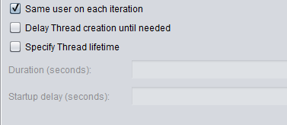

**Same user on each iteration:**

**Specify Thread lifetime:**

**Duration** **(Seconds):** It will execute the test specific time ex. 60 sec execution ends after 60 second it will not check all thread has complete its test or not .

**Startup delay(seconds):** wait for specific time before starting test.

**Logic Controller**

**Description:** It will decide when and how to send the request to server.

**How to Add:** Right click on Test Group. Add -> Logic Controller - > <Select any controller>